IEEE Washington Section
Chapter Officers’ Survival Guide
Frequently Asked Questions

Jan 2023

Table of Contents

Chapter Chair’s FAQ
- I’m both Chair and Treasurer. Help!
- Our Chapter officer assignments have been static.
- Who can be a Chapter Officer?
- Where and when are the AdCom meetings?
- Who is on the AdCom?
- So what do these folks do?
- What’s the name of my Chapter?
- How many members does my Chapter have?
- What does a Chapter do?
- I’m having trouble holding meetings.
- I have never heard of a “Distinguished Lecturer”.
- I am not involved in the national Society.
- I don’t have enough bandwidth to do this by myself.
- I’m not going to do all of this work for IEEE to get nothing out of it!
- What location should I pick for meetings?
- I have a project that’s important to me.
- I know a training company that is in the business of selling technical and professional seminars.
- There are some non-IEEE professional societies operating in the DMV.
- How do I effectively use vTools?
- There are fields to fill out for “Organizational Unit”, “Contact Email” “Co-sponsor name?
- I’d like to list my University in the sponsor or co-sponsor field in the Event Announcement.
- Who should I list in the Event Announcement as the contact person?
- How does a co-sponsoring OU use vTools?
- Does a co-sponsor share in the costs for the event?
- My Chapter is one of 3 Chapters that co-sponsored a Saturday workshop.
- How do I get money for my event?
- Why do I need a damn budget?
- I have a CB account so I’ll make up a budget.
- How much money do the Chapters have?
- What are the 14 Chapters doing with their stash?
- What if I don’t submit a budget?
- How do I get money from my Society?
- How do I get money from NoVA?
- Do the two Sections cooperate?
- I’m not going to submit a budget.
- I can’t make it to the AdCom meetings.

Chapter Chair’s FAQ

- I’m both Chair and Treasurer of my Chapter. Help!

Contact the Washington Section Chair. Ask advice on how to expand your cohort of Chapter volunteers. Come to the Section AdCom meeting to discuss your situation.

- Our Chapter officer assignment(s) have been static. Nothing changes, year after year after year.

Contact the Washington Section Chair. Ask for advice on how to expand your cohort of Chapter volunteers. Come to the Section AdCom meeting to discuss your situation.

- Who can be a Chapter Officer?

All Officers must be a member of one of the Sections in which the Chapter operates. Of course, a Chapter Officer must be a member of the technical society of the Chapter.

Chapters have two kinds of affiliations: a geographical attachment (to one or more Sections) and a technical activity attachment (to a Society or Council or Affinity Group). Chapters or Affinity Groups which are listed as belonging to more than one Section are called Joint Sections Chapters (or Joint Sections Affinity Groups), in which case they have a primary parent Section and one or more secondary Sections.

There is a confusing nomenclature in IEEE regarding Joint organizations. A Joint Chapter is a Chapter that belongs to and serves the members of more than one Society. A Joint Sections Chapter is a Chapter that belongs to two or three contiguous Sections, with one of the Sections serving as the primary Section (also called the lead Section or the parent Section). The primary Section is responsible for administering the funding for the Chapter, while the other affiliated Sections are responsible for sharing in the support.

- Where and when are the AdCom meetings?

The Washington Section Administrative Committee (AdCom) meeting takes place once a month.

Before the restrictions of 2020, it was scheduled usually on the second Thursday of the month. It can be anytime that the AdCom decides.

The current location is the College Park Aviation Operations Building Conference Center, which is in the building to the left of the College Park Aviation Museum. Parking is free in the museum lot after museum hours or in the adjacent Operations Building lot if the Museum is still open. The meeting location is only a short walk from the College Park Metro Station. The location is http://collegeparkairport.aero/attractions.html4
The meeting room is on the 2nd floor of the Operations Building.
College Park Airport Operations Building
1909 Corporal Frank Scott Drive
College Park, MD 20740

Note that the adjacent Museum actually has a different address, 1985 Corporal Frank Scott Drive.

As is customary at all IEEE meetings, dinner is served.

- Who is on the AdCom?
The Washington Section Executive Committee (ExCom) consist of 15 positions: the 4 officers (Chair, Vice-Chair, Secretary, and Treasurer), the Past-Chair, the 8 Directors, the Student Activities Chair, and the Student Representative. A majority of the ExCom (8 people) must be present for the Section to conduct any business.
The ExCom (by majority vote of those present) must approve all spending of the Section.

The Directors serve a 2 year term, with half of them rolling over each year. The rest of the ExCom serve a 1 year term. All terms are from Jan 1 to Dec 31, except for the Treasurer, who stays in office an extra two months so he can overlap with the incoming treasurer and they both can participate in completing the Section’s financial reporting in February.

The Administrative Committee (AdCom) consists of the ExCom plus all of the Chapter Chairs (or Chapter Delegates) of each of the Chapters attached to the Section, and all the committee Chairs.

- What does the AdCom do?

It is at the AdCom meetings where the vote is held on the fiscal activities of the Section. If you attend the meeting as your Chapter Delegate you of course provide input as to how the AdCom spends its money and how much money your Chapter receives for its meetings.

The Section is funded by IEEE according to a formula that depends on the level of prior year Chapter meeting activity and the local IEEE membership numbers. This funding is then used to reimburse Chapters for their meeting expenses, and to fund activities run by the Section itself.

Some of the Section’s recurring activities have been support for awards to our local high school Science Fair winners (when they have IEEE-related topics, a free annual summer picnic for IEEE members and their guests, an annual banquet for IEEE members and their guests, and support for workshops and tutorials that are targeted to a general broadly-based IEEE membership, especially targeted to members who do not elect to belong to one of the technical Chapters.

- What’s the name of my Chapter?

Good question. It is probably not exactly what you think it is.
There is a proper title in the IEEE database. IEEE has trouble keeping the style it uses to name your Chapter consistently applied.

The Section name is part of your Chapter name. Your Chapter belongs to either the Washington Section or the Northern Virginia Section or is jointly owned by both Sections, with one of them as primary.
Some IEEE jargon:

OU: Organizational Unit -- the name of an IEEE Section, Chapter, Group, etc
SPO ID: Service Providing Organization ID -- a text string identifier for an OU
Geocode: Another more commonly used term for the SPO ID

Our Section’s geocodes are 20019 for the Washington Section and R20049 for the Northern VA Section.

IEEE’s various databases may style your Chapter name in a variety of ways, usually because they abbreviate the Section names or display them in different ways. The Section names are rendered with many variants and no rules. This lack of consistency makes it difficult to find your Chapter in the ordered lists or searchable databases inside IEEE if the search depends on an exact match. For example, here are the listed names of some of our Chapters, with geocode and name:

CH02101 - Washington/No VA Jt Sections Chapter, EMB18
CH02182 - Washington/Baltimore/No VA Jt Sections Chap, CAS04
CH02094 - Washington/Balt/No VA Jt Sections Chap, NPS05
CH02109 - Washington Section Chapter, COM19
CH02180 - WA/No. VA Jt Sect Chap, TEM14
CH02146 - Northern Virginia/Washington Jt Sections Chap, PE31
CH02167 - Northern Virginia/Wash Jt Sections Chapter, NANO42
CH02173 - No Virginia/Washington Jt Sections Chapter, CIS11

And there may be other variants not listed here.

Your Chapter’s Society is designated by a 3 or 4 character acronym followed by a numerical suffix, for example MTT17, NANO42, COM19, etc. The suffix belongs to the Society, not the local Chapter.

You can look up your official Chapter name and geocode by querying any of the databases. Try the Officer Reporting tool in vTools as a start.

- How many members does my Chapter have?

A good question, one that takes some work to answer. As a Chapter officer you should know how many members in your Chapter are registered in Washington and NoVA, and also in Baltimore if you are a tri-Section Chapter. Visit IEEE OU Analytics or ask the Section or the Society for help. Consider it a homework assignment. Looking for this information is a way to learn about IEEE. Good Luck!

- What does a Chapter do?

The Chapter mission is to hold local technical presentations, workshops, or seminars so that their members can keep up-to-date locally without the commitment they would need to attend IEEE conferences.

Chapters may occasionally hold social events like picnics, technology tours, sports outings, casual dinners and other similar events to encourage professional networking, but most of those types of activities are done, and should be done, at the Section level. Instead, your Chapter funds are expected to be used for technical events that support the topic areas of your Technical Society.

Affinity Groups, on the other hand, are primarily social. If you would like a rule to guide your activity choice, here it is:

- Chapters are IEEE OUs that hold technical meetings with some social engagement.
- Affinity Groups IEEE OUs that hold social meetings with some technical engagement.

To pull this off, Chapters ideally operate with 4 officers: chair, vice-chair, treasurer, and secretary. It is entirely correct to expect that the vice chair will eventually take the chair’s post and that all officers will move up the ranks. Therefore a major role for all officers is to recruit and groom newer members to participate in due time as officers.

If there is no bank account, a treasurer is usually unneeded, and the treasurer’s role can be combined with one of the other officer’s role.

Unfortunately, Chapters sometimes cannot fill all the posts, and regrettably there is only one officer, the Chair.

Here is the approximate sequence of Chapter actions through the year:

  - Report new Officers in vTools in early January
  - If your Chapter has an IEEE bank account, register 2 treasurers (one is primary, the other serves as backup) with MGA so financial actions can be made. The Chair is often the back Treasurer.
  - Send one or more delegates to the Sections’ Officers’ Training meeting, usually in late January or February. Training is mandatory for treasurers and all new officers.
  - Submit your budget to all of your Sections if you have an IEEE account.
  - Hold technical meetings
    - Create the Event Announcement
    - Send eNotices
    - Hold the Event
    - File the Event Report
    - Request reimbursement if you do not have an IEEE bank account
  - Repeat above step e) n times.
An excellent goal is n=4: 2 talks in the spring and 2 in the fall.
The minimum requirement is 2 per year to receive funding the next year.
  - Attend the Annual Awards Banquet (spring) and Annual Picnic (summer).
  - Attend (or send a delegate to attend) the Section AdCom meetings, including both Sections if joint.
  - Represent your Chapter at your Society’s annual Symposium and report your status as the Society may require.
  - Co-sponsor other OU’s meetings throughout the year only if the topic is relevant to your Chapter.
  - If you have an IEEE bank account, follow the reporting requirements through tht year as neede
  - Recruit new Officers for next year.

- I’m having trouble holding meetings and finding speakers. But other Chapters seem to be doing well. To get my minimum of 2 meetings a year I could just co-sponsor their meetings.

Every year, there seems to be one or two Chapters that have difficulty in creating their own program so they opt to satisfy the requirement of 2 meetings/year by glomming onto another Chapter’s activity. If they only co-sponsor online meetings that are managed somewhere else, they really haven’t done anything.

Well, that works in the short term, but it’s not sustainable. Chapters are chartered by their Technical Societies to run meetings targeted to the topic area of their Society. They are not funded to give their money away to a different Society’s Chapter, unless of course the topic of the meeting is truly of joint interest. Co-sponsorship is not acceptable if the co-sponsoring Chapter’s charter has little or no topical overlap.

The IEEE members pay their fees to a Society so their Chapter can sponsor relevant meetings and the Chapter Chairs must respect that fee and target their meeting topics to the Society’s topics accordingly. While co-sponsoring activity is allowed and encouraged, it cannot displace the requirement for a Chapter to run its own program.

We have heard the argument over and over again that in collaborating with other OUs the co-sponsoring Chapter provides a valuable service to its members by recognizing the members’ multidisciplinary interests. All true. The problem arises when the co-sponsoring activity is the only activity the Chapter engages in because they never initiate any activities of their own. So please let us end this discussion now and agree that a Chapter is responsible for originating its own meetings and that co-sponsored meetings are supplemental activities.

How do you get speakers? Well, even if you don’t really know who to contact, you still can pick up a Distinguished Lecturer from your national Society to come to the DC area to deliver a lecture at very low cost. With sufficient advertising and outreach, these national and international experts can draw very large crowds.

- I have never heard of a “Distinguished Lecturer”.

Really? Have you read the IEEE website? Have you visited your Society’s website?

As a Chapter leader you should know that your Society maintains a list of Distinguished Lecturers who travel around the US and the world to visit IEEE Chapters. We are fortunate that they very often visit the Washington metro area anyway on business travel and will be glad to stay an extra day to give a Chapter talk. The Society usually picks up the travel expense, the Chapter picks up local expenses (like taxi fare), and may even take the speaker to dinner with the Chapter Committee, at IEEE expense. Go to your Society website and find out what your Society supports!

See https://www.ieee.org/about/volunteers/tab/distinguished_lecturer_program.html

- I am not involved in the national Society. I actually don’t know very much about my Society.

Well, you are still a member of IEEE, so if you want to run a Chapter, you should find a way to get involved in your Society for real.

- There were a lot of people working with me for my Chapter. But they have all moved on and now I am the only one left. I don’t have enough bandwidth to do this by myself.

Understood, totally. Life happens. Most of our volunteers have gone through a time where they seem to be the only one left interested in putting time into their Chapter. It can be hard to sustain continuous involvement as a volunteer. If you cannot recruit someone to replace you, please let the Section know the status and ask for help.

- The only way I can rationalize volunteering for IEEE is if I entwine and entangle IEEE activities with my job. Everyone can see that IEEE is a Cash Cow and the money is sitting there waiting for me to use it. By being assertive and claiming I am working in the interest of “Science and Technology”, I can divert IEEE funding to support activities that can benefit me personally. I can use IEEE funding to support my company, my University, my local high school, my charities, my students, my Cub Scout pack, my STEM summer camp, my consulting business, my robotics club, etc. To be brutally honest with you, I’m not going to do all of this work for IEEE to get nothing out of it!

Clever thinking. Superimposing your career with your IEEE service is expected and normal. However, exploiting the IEEE funds to efforts that enhance you and yours is not admired. In politics this would be called “business as usual” unless it is pointed out by the opposition party, in which case it is called “corruption”.

You are supposed to be spending IEEE funds to benefit all the dues-paying members of your Chapter, not just you and your personal realm.

- What location should I pick for meetings? Should I choose my Corporate Conference Center, which requires 3-day advance registration and an internal budget line to charge against? Or a government facility’s conference room at 10:00 am, where every visitor must register 2 weeks in advance to clear a security check, foreign passport holders are banned, and all visitors must submit a DNA sample, be badged and escorted at all times? Or what about the University seminar room at 4:30 pm, it has $16.00 visitor parking 2 kilometers away, so really only my grad students on campus will attend? Or how about the County Library: free meeting rooms and free parking, but only available during lunch? Or maybe something with Metro access?

Where to hold meetings is the toughest choice a Chapter has to make. There is a scarcity of low-cost ideal meeting space in DC, Maryland, and NoVA. The only real criteria for a meeting venue is whether your Chapter members can and will get there. So please try to hold your meetings at locations and times when your Chapter members can show up. Please do not, merely for your own convenience, choose to effectively limit your constituency to those attending your university department during the day, or the people who are already within the security perimeter of your company at lunchtime. You are responsible for reaching all the members of your Chapter. The folks who pay for the funds you spend are the ones who should get the benefit of your spending.

If you are a Joint Sections Chapter and receive funding from both Sections then you are obligated to serve people on both sides of the Potomac River so that Johnny Reb and Billy Yank can both benefit, no matter who is the primary Section or where you work or live, even if you have to cross a bridge in rush hour.

- I have a project that I would like to fund. How do I get the Section to pay for it?

Come to the Section meeting, show the Section that your project benefits IEEE members, present a proposal with a budget, and ask for funds.

Your event should be relevant to IEEE members, not just a “technology” or “STEM” event. For example, we will not fund you to work a technology project with your local neighborhood Cub Scout Pack (the one your kids go to) because while we agree the goal is justifiably admirable the target audience is very narrow because it is locally restricted. We do not want to have our funds funneled back to an organization that was selected for funding only because you are personally associated with it and your kids and your neighbors are the ones getting the benefit.

An event that targets IEEE professionals with a social component (even if the social component is actually enjoyable) has a good chance of being funded, unless the Section’s funds are depleted. But all S&T topics are not necessarily IEEE topics. The key requirement is that the connection to the IEEE mission and members must be real, not artificial.

Raise your request for funding early in the fiscal year. Please don’t appear at the Section meeting with a receipt and sad expression asking us to bail you out of the money you paid by asking us to reimburse you after the fact. All expenditures of the Section are either included in the year’s budget, which is approved by vote of the AdCom at the beginning of the year, or else they may added to the budget by vote at the next AdCom meeting.

- I know a training company that is in the business of selling technical and professional seminars associated with professional certifications. They agreed to offer a version of their seminar to my Chapter. I could host their seminar as an IEEE-sponsored event and invite my Chapter. The company will go along with IEEE branding because I can deliver an audience of likely customers, and they will get publicity and an apparent IEEE endorsement. And I can get a meeting out of it without doing anything other than sending out the eNotice.

Look, it’s a common strategy for these companies to offer a starter seminar or workshop for free so they can pitch the higher-level paid version of the workshop to the attendees. They are using you to get to the IEEE mailing list to enhance their business. If the topic is truly relevant and specific to your Chapter, then no problem, go for it, but in that case you should require that the company pay for the F&B and pay for the room. They should be sponsoring us out of their marketing budget, same as if they were hosting an industrial show at a conference, you should not be sponsoring or co-sponsoring them using member’s dues. The last time we looked, IEEE was not a subsidiary of any for-profit entity.

Also, remember that no company or speaker can get your IEEE meeting sign-up email list – instead the speaker can ask for the attendees to opt in. You must protect your sign-up lists from distribution outside IEEE without the member’s authorization. Now that IEEE follows the GDPR data compliance rules, you should not even be storing email lists. If your speaker insists that he needs the contact info list to justify his marketing expenditure, you will then know you are being played, but do not give it up, to do so is a violation of IEEE policy.

No one may get an IEEE member’s contact info without the member’s permission to release it. The member contact info is not yours to give away.

- There are many non-IEEE professional societies operating in the DMV who offer excellent programs that are of interest to my members. I could tell my Chapter about them and pretend that IEEE is involved with them, by calling their meetings an “IEEE Partner Event”. I can bring the IEEE brand, IEEE vTools communication, and IEEE funding to them, and they will be very happy to have IEEE publicity. They will handle everything. They will produce the meeting and get the speakers with no participation from me or my Chapter. All I need to do is promote the meeting in vTools and of course, give them some IEEE money. Then I can report the meeting as my Chapter event and I will have activity to show for the year. If I do this twice, I don’t even have to plan any of my own meetings. Isn’t this a good plan?

Almost always it is a bad plan. This can only be a good plan if you are not passively subsidizing another organization with IEEE funds. The event must be publicized as jointly-sponsored by IEEE, not just in your vTools marketing material but also in the non-IEEE organization’s marketing materials. Your Chapter must be involved in a material way in the program. Funds should only be provided if the amount is proportional to the number of IEEE participants and reasonable for that event.

It sure looks like a potential conflict of interest if you allocate funds to a non-IEEE organization that you are also a member of unless in doing so you return direct value to the IEEE membership.

Your Chapter funds come from the IEEE members' annual dues, and the Chapter members do not pay their dues for you to give them away to a different non-profit. If IEEE members want to pay dues to join the “Mid-Atlantic & Chesapeake Society of not-IEEE” then they can decide to do so, individually. You don’t get to decide for them.

But there is a way to cooperate with another organization, if you are an equal partner. Suppose your Chapter co-sponsors a non-IEEE-hosted meeting that requires an attendance fee. If you negotiate a heavy discount in the registration fee for IEEE members, and pay for the discount with your Chapter funds, then if no from your Chapter attends, you pay nothing. Your co-sponsorship cost is proportional to the IEEE attendance and you are providing a real value to your members. You subsidy is not a gift to the non-IEEE organization, but is a purchase for your members, who by registering for the meeting have elected to spend their Chapter’s funds. If no IEEE member registers then your co-sponsorship cost is zero. It is easy to see in this case that your members, not you, have chosen to use Chapter funds by registering, you have just arranged the discount for them. This is a good working model for how to effectively broaden your members' access to the best technical meetings and seminars in the area.

- How do I effectively use vTools to create and report meetings?

In the following,
“OU" is IEEE-speak for Organizational Unit
"Host" is IEEE-speak for the primary OU responsible for an Event

The troika of communication tools that you use to conduct your meetings are all accessible from the vTools website at https://meetings.vtools.ieee.org/ .

These tools are Event Announcements, eNotices, and Event Reports.

Here is a step-by step procedure:
- Visit vTools Events
- Select Event/Report Administration.
- Select Schedule a New Event
- Fill out all the fields that are relevant
  - In the Host field, assign the Host from the drop-down menu.
  - Each Event Announcement has a single unique Host
- Send eNotices to the target members, referencing the URL of the Event Announcement
- Hold the event, capture the number of attending IEEE members and the number of guests.
- File the Event Report from the Event/Report Administration page, or “Manage” the event and add the attendance numbers there.

You can be sure that while every IEEE member can choose to login to the vTools site and search for Event Announcements, virtually no one will bother. To reach your members, each co-sponsoring Chapter should send out one or more eNotices (a blind email originating from IEEE, sent to the targeted group) alerting the targeted members to the upcoming meeting. These eNotices should have a short message and include a link back to the original Event Announcement URL. By using the “Express” option, the email will be sent a few hours after you submit it.

It is best practice to ask your attendees to register online for your meetings so that you can get an advance head count for F&B (food and beverage). Remember that IEEE members expect you to host them, so be gracious and offer reasonable and appropriate F&B. Contact the Section if you need ideas on what to do.

- In the vTools Meeting Announcement there are fields to fill out for “Organizational Unit”, “Contact Email” “Co-sponsor name? How do I choose?

The Organizational Unit (OU) is selected from a drop-down menu so you cannot enter it arbitrarily. It should be the primary OU that initiates the meeting. The name is rendered in the formal IEEE OU style, such as
“CH02102 - Washington/No VA Jt Sections Chapter, EMC27”, etc.

The Co-sponsor Name is entered manually, so it you can type it informally, such as “Wash/NoVA MTT Chapter”.

- I’d like to list my University or my Company in the sponsor or co-sponsor field in the Event Announcement.

Don’t do it. This idea would not even occur to you if the Event was really organized by your Chapter. The confusion usually arises whenever your Chapter has minimal or no involvement and is just lending their name to Somebody Else’s Event. Please remember that a sponsor or co-sponsor is an IEEE OU, either a Section, Council, Chapter, Affinity Group, etc. IEEE organizations, not people, are sponsor or sponsors.

Because the sponsor or co-sponsor cannot be a person or a non-IEEE organization, if you wish to acknowledge the role of a person or a non-IEEE entity, put it in the text of the announcement, but do not list them as the sponsor or co-sponsor.

Be aware that entries in the "Co-sponsor" field in the Event Announcement are only for the reader's information and are not part of the post-event reporting process.

- Hosts are OUs and are selected from the drop-down menu
- Sponsors and co-sponsors are IEEE OUs, never people or non-IEEE organizations..

- Who should I list in the Event Announcement as the contact person?

The Contact Email should list an IEEE Officer (Chapter Chair or Secretary, usually) of the primary sponsoring OU. The contact email must not direct to a non-IEEE person, even if that person is actually running the affair for you behind the scenes. If you feel that contact referral to non-IEEE persons is needed (say, for parking permits, late-breaking weather-related notices, etc.) please put that in the text of the Event Announcement.

- Contact info must direct to an IEEE officer of the sponsoring OU

- How does a co-sponsoring OU use vTools?

Co-sponsoring OUs should not create duplicate Event Announcements, instead they should cite the original Event Announcements by its URL.

There must only be one authoritative Event Announcement. Duplicates are not needed and can cause trouble if the info is not identical. If changes are needed, update the single original.

Even if the co-sponsors are equally involved, one of them must author the Event Announcement. The phere should be only one authoritative Event Announcement located at one URL, with a unique site for registration. This ensures that there are no copies with conflicting times, dates, locations or multiple registration rosters.

The OU that authored the Event Announcement will file the attendance Report, and all the sponsoring OUs will get credit.

- Does a co-sponsor share in the costs for the event?

Yes. Co-sponsoring is not free. You cannot be a co-sponsor if you do nothing and pay nothing. Sending an eNotice to your Chapter alerting them to an event does not make you a co-sponsor. A Chapter that only co-sponsors 2 meetings a year that are organized by someone else, for which all they did was copy an eNotice has spent about 5 minutes a year to qualify for their funds. That may be good enough to keep your Chapter listed as active with IEEE MGA, but be assured that the Section is well aware that you aren’t doing anything.

Chapter Chairs who co-sponsor meetings should pre-negotiate a cost-share arrangement with their other co-sponsors, and show up at the event to assist in logistics. If they need Section funds to reimburse their expenses they should report the cost-sharing arrangement by submitting a financial statement of the event to the Section, or to both Sections if any of the participating OUs are Joint. Such cost-share arrangements may call for an equal split among all co-sponsors, or may be split according to whatever the Chapters agree to.
- Here is a homework problem you have to solve if you want to be involved in co-sponsoring meetings.

Consider the following facts:
- 3 Chapters co-sponsored a workshop.
- Chapter 1 does not have a HOP account.
- Chapter 2 has a HOP account.
- Chapter 3, which does not have a HOP account, didn’t help out and their folks didn’t show up, but they want to get credit for the meeting so they must share in the cost.
- 37 attendees paid a $20 registration fee each, collected by the Section via PayPal.
- The Section’s PayPal fees were $36.52.
- Chapter 1 bought the continental breakfast for $266.40 and lunch for $799.20.
- Chapter 2 purchased some workshop supplies for $39.00
- Chapter 2 paid for the taxi fare for 2 of the speakers for $16.50 and $19.00.

How do we settle this mess?

We suggest you fire up a spreadsheet and lay out a table. This is accounting, not mathematical physics, so the correct answer is the one for which consensus among those involved is reached. Pass it around to all Chapters involved and when everyone agrees, cut the checks among yourselves as needed or send it to the Section if the Section needs to reimburse. Here is our solution:

- How do I get money for my program?

It is a bit complicated. Here is the Chapter funding model agreed to by the Sections.

Chapters receive $200 per year from IEEE if they
- held at least 2 technical meetings in the prior year
- filed all of their required meeting reports in the prior year
- filed all of their required financial reports in the prior year

Chapters receive an additional $75 bonus from IEEE if they held at least 6 technical meetings.

These funds are paid to the primary Section who then gives it or allocates it to the Chapter.

In addition the Sections subsidize the Chapters that submit budgets, at a level of $240 from each Section.
Single Section Chapters thus can receive $440, and thus Joint Sections Chapters can receive a total of $680 for the year.

How you are given these funds depends on whether your Chapter a) has or b) does not have a CB account:

  - If your Chapter has a CB account, you can fund your meetings from your account reserves, or you can ask for advance funding at the beginning of the year by submitting a budget. The budget you submit is the document that shows where your income is coming from and how you are spending it. A submitted and approved budget allows us to fill up your checkbook and authorizes you to spend the money. Your Chapter treasurer archives the receipts after the spending. Spending is then supported by a document trail maintained by your Chapter Treasurer, not the Section.

  - If your Chapter does not have a CB account, you cannot receive advance funding (because we have no place to send it) and then you do not need a budget. Unfortunately this means you must self-fund your activities out-of-pocket and then submit your receipts for reimbursement. Your reimbursement is capped at the amount pre-approved by the Section at the beginning of the year. However, if you exceed the cap, just ask us to allocate more. If we still have funds then you can spend above the cap. You should let the Section know that you are intending to have more meetings and will be submitting more receipts.

- Why do I need a damn budget? Just give me my money. I know how to spend it. Why is the Section micromanaging me?

The money that your Chapter receives from IEEE is not a gift. It is extracted from the IEEE members when they pay their dues, with much grumbling. IEEE gives it to the Section to manage, and the Section gives it to you to manage for the members of the Chapter.

If the Chapters create and hold technical meetings and report them in a timely way there is no need for management, macro or micro. The purpose of the budget submission requirement is to let the Sections know that you are active and working on delivering a technical program for your members. So you need to show the Section that you are using it for the members’ benefit. We can actually give more to your Chapter if you will actually create and hold more technical meetings.

Recall how you got to be a Chapter Officer. Did you hold an election among all the members of your Chapter? Did you win the popular vote or just the Electoral College? How many of your Chapter members even cared to cast a ballot?

The truth is, even though there is a formal election process available, Chapter leaders are usually recruited by the prior leadership and take the post unopposed in some sort of ad-hoc selection process, as the prior leadership fades away. But even though the circumstances of your rise to Supreme Executive Power is checkered, you owe the masses your best effort to serve all of them.

- OK. I have a CB account so I’ll make up a budget. What does it look like?

Here is what a typical budget looks like:

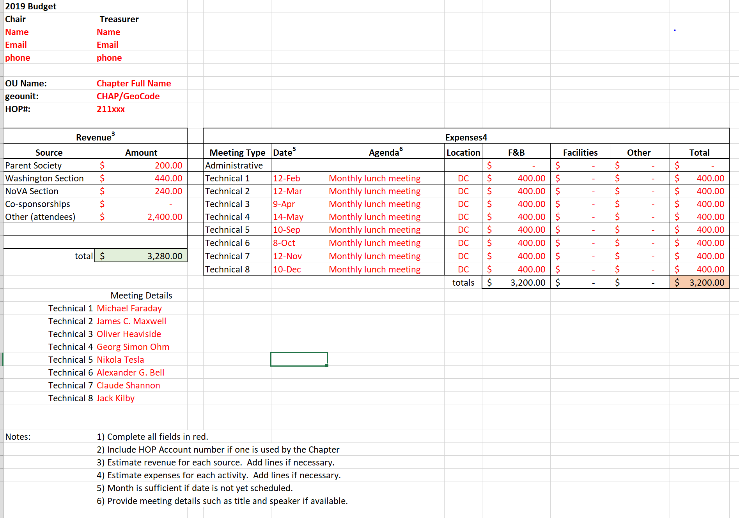

These are all round numbers because the lectures haven’t happened yet. Notice that you list all of your expected sources of income, and list all of your expected expenditures. You may not have all of the income categories shown here and you may not have all of the expense categories, so just list what you expect. Be more specific if you can – tell us who the sponsors are and what date the lectures are planned for. You and your Chapter Committee should know what the cost projections should be because you have run many similar meetings.

Notice the key features of your budget:
- A minimum of two technical events
- You ask for only the funds that you really intend to spend
- You really intend to spend everything you ask for

This means you must put some real thought into the budget process. Please do not just duplicate the template and fill it with phony numbers.

If an event does not happen, for example, if a speaker cancels or you are frozen out by a light dusting of snow and you cannot re-schedule, you get to keep the unspent funds in your CB account and re-cycle them to new events in the future.

- What if I don’t submit a budget?

If you don’t submit a budget, you can only receive the IEEE rebate (if your chapter qualifies) after it is received by the Section – you have no choice but to fund your events from your reserves. The budget is not just a table of numbers, it is your Chapter’s yearly declaration of intent; a thoughtful, planned and realistic proposal to hold real Chapter meetings and technical lectures that meet the IEEE mission. If you don’t hold technical meetings, well, why are you running an IEEE Chapter?

If you want help in formulating the budget, then ask us for help, and we will help you. Don’t be shy.

- How do I get money from my Society?

Why don’t you ask them for it? Which means they have to know who you are. Find out who the Society’s Chapter Coordinator is and what their funding policy is. Go to their national Symposium and attend their Chapter Chair’s meeting as your Chapter’s representative. Give them a presentation on your recent activities. Little known fact: many Societies will pay the expenses for travel to their Symposium for a Chapter Chair or Chapter delegate. Each Society is different and their policies vary.

Society funding for Chapters can exceed the amount that the Sections have available ($1000 is not uncommon), and the funds are mostly untapped because Chapter officers that are not nationally active in the Society are unaware of it. The funding is probably sitting there waiting for you to capture it!

- I run a Joint Sections Chapter. Washington is the lead Section, NoVA is secondary. How do I get money from NoVA?

You have to ask them for it. Do they know you? They will want to know what you will do with it. Joint Section Chapters are pre-authorized for $240 from the secondary Section but NoVA may wish to discuss your activities and ask you to show that you are spending it on their side of the Potomac before they give it up. The purpose of the Section subsidy is to fund you to hold meetings that serve their members.

So show up at the NoVA AdCom meeting and make a pitch. Bonus: they are nice people and also serve dinner.

- Do the two Sections cooperate in funding my Joint Sections Chapter?

Yes, they cooperate very well, although early on that may not have always been true.

Below is a lithograph showing the first joint meeting of the IEEE Washington Section and the IEEE Northern Virginia Section held in Manassas, VA on July 16, 1861, just about 4 months after Abraham Lincoln took office.

It shows the two Sections thoughtfully and graciously negotiating the thorny budget issues concerning the allocation of funds to the Joint Sections Chapters.

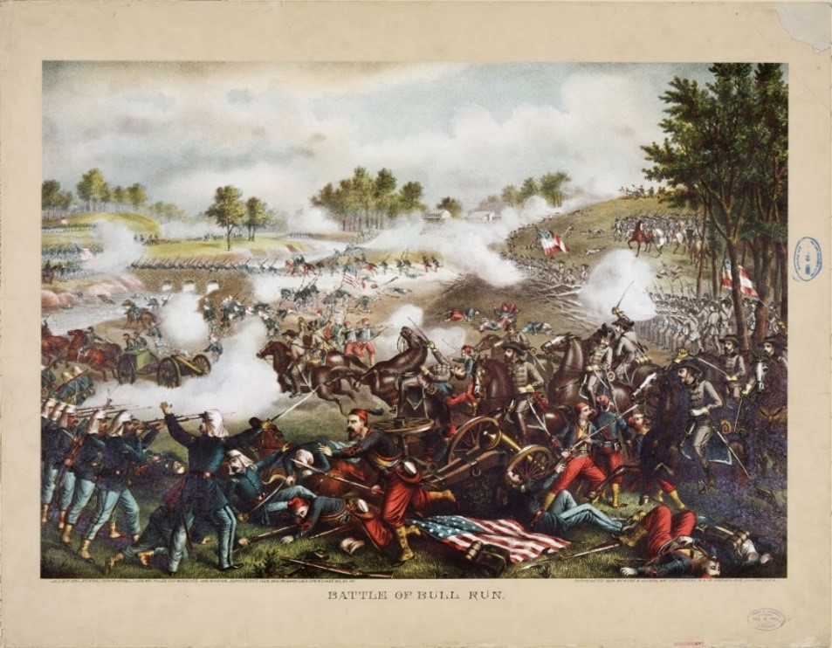

The first joint meeting of the IEEE Washington Section with the IEEE Northern Virginia Section on July 16, 1861 in Manassas VA, where thoughtful and gracious discussions of thorny budget allocation issues were held. Kurz and Allison Lithograph, Library of Congress, Public Domain

- I am not going to submit a budget. I never have in the past. I don’t plan my Chapter’s events in advance. I just wing it. I’ll just keep co-sponsoring whatever other folks create. It won’t cost anything. I just don’t have time to create an original technical program of my own.

Well, if your technical program is always created by somebody else and not by you, then we don’t really need you, do we? We need the other guy. But if you want help in running you own technical program, let us know.

- I can’t make it to either the NoVA or the Washington AdCom meetings because I am too busy and too far away. To be honest with you, I don’t really know a lot about what my Society does anymore because I don’t keep up with the field. The only reason I am still Chapter Chair is because there is nobody else left to do it.

Well, that is certainly regrettable, but you are not alone. There are a few Chapter Leaders that are passive and idle year after year, with little in the way of real Chapter activity. Eventually IEEE and the Section will catch up to them and de-activate the Chapter. If you have trouble, please consider recruiting help to run your group, or contact the Section and ask for help. Nobody wins if your Chapter goes out of business. We don’t want you to lose the Chapter because of idleness and we assume you don’t want to either. So let us know what’s going on and we will work with you to get it going again!

