The Engineers Club of Philadelphia,
Pennsylvania Society of Professional Engineers
Philadelphia Chapter &
Philadelphia Section of IEEE
Rail Park - Evening Tour

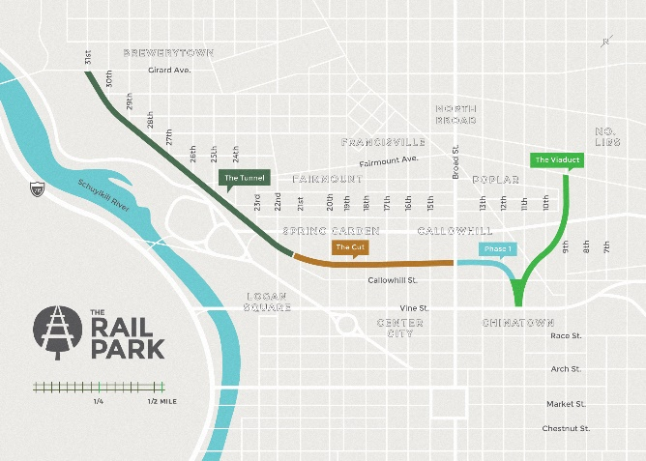

Thursday, September 5, 2019

Registration & a Hoagie in a Bag: 6:00 PM to 6:30 PM

Guided Tour 6:00 PM to 7:00 PM
Non-Guided Tour – After 7:00 PM

Presented by
Angelo J. Waters, PE, Leed AP
Vice President - Environmental Services
Urban Engineers, Inc.

The Pennsylvania Society of Professional Engineers, through PIE, will evaluate and may approve the “activity” for the continuing education license requirements for 1.0 Professional Development Hour in New York State. PSPE believes the “courses” will be accepted for credit in PA, NJ and other National Model states where courses do not require pre-approval.

Tour Starts at:

Corner of Broad and Noble Streets

Price using Paypal - $15.00

FOR RESERVATIONS GO TO:
http://www.pspe-philly.org

