**Krishna M. Pasala,Ph.D.   
Memorial Scholarship**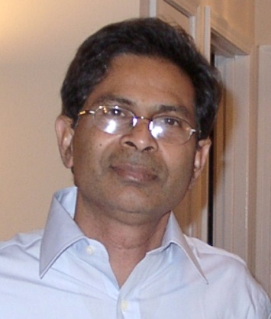

**Krishna M. Pasala, Ph.D. Memorial Scholarship**

To pay tribute to the late Professor Krishna M. Pasala, the **IEEE** **Krishna M. Pasala, Ph.D. Memorial Scholarship** was established by the IEEE Dayton Section in 2012**.** This annual Scholarship recognizes the academic excellence of one graduate student within the Electrical and Computer Engineering department of the University of Dayton. The student must be an active IEEE member. The scholarship award (up to $1000) may be used toward the purchase of books or other educational materials associated with education innovation.

**About Krishna M. Pasala, Ph.D.**

Professor Krishna M. Pasala, Ph.D. was an internationally recognized scholar and dedicated teacher working in the areas of electromagnetics, antennas and adaptive signal processing. For more than 25 years, he combined a career of enthusiastic teaching, innovative multidisciplinary research, and mentoring of undergraduate and graduate students, and faculty. His tireless efforts resulted in strong partnerships between The University of Dayton (UD) and the Air Force Research Labs (AFRL) in both collaborative research and course offerings. Dr. Pasala was instrumental in forging a strong and continued relationship between AFRL and UD and more recently with IISc in India. His work was published in numerous prestigious journals including IEEE publications. His work is often cited in Aviation Week and Space Technology and is a testimony to the level of cutting edge research that he and his research group performed. Professor Pasala was a devoted family man. He is survived by his Wife Usha, and Daughters: Swapna, Prasanthi, and Kavitha.

**IEEE Foundation Fund in support of the Krishna M. Pasala, Ph.D. Memorial Scholarship**

**Call for Applications**: The Dayton Section of IEEE requests application package due: January 15, 2015.

* Completed application form with General information and qualifications (blank form attached)
* One page personal statement of attainments, interests, career intentions, and goals
* Statement of intended use of the funds in the area of educational innovation
* Official transcripts of all university/college work
* Link to application and submission details: <http://sites.ieee.org/dayton/?p=583>

**Submission Details:** The scholarship candidate application packages will be submitted directly to the University of Dayton ECE Department; Attention: Scholarship Chair for IEEE Dayton Section Student Scholarship Selection Committee at [john@johnmalas.com](mailto:john@johnmalas.com) .

**Award Details:**

* Scholarship recipients will be notified in February 2015 and featured in the Dayton Section Monthly Newsletter: *The Mini Conductor.*
* The memorial scholarship will be formally presented at the annual IEEE Dayton Section Awards Banquet scheduled in April each year in the form of an award plaque and check.

To learn more about the IEEE Foundation and the ***Fund***, please visit [www.ieeefoundation.org](http://www.ieeefoundation.org/) or IEEE Development Office at 732-562-3915 or email donate@ieee.org.A description...

[***www.ieee.org/donate***](http://www.ieee.org/donate)

Application for IEEE Krishna M. Pasala PhD Memorial Scholarship Fund

1. Full Name Last: _________________ First:___________________, MI: ____________________
2. Approved Academic Program of Enrollment at the University of Dayton: ________________________ __________________________________________________________________________________
3. Academic Advisor: ___________________________________________________________
4. Current and following Term Full-Time Enrollment in Graduate Studies:

Number of Graduate Hours Enrolled in Current Term: __________

Number of Graduate Hours Planned for Enrollment in Following Term: __________

1. Summary of Academic Accomplishments: __________________________________________________ ____________________________________________________________________________________

____________________________________________________________________________________ ____________________________________________________________________________________ ____________________________________________________________________________________

1. Academic Awards, Scholarships, Honors: __________________________________________________ ____________________________________________________________________________________ ____________________________________________________________________________________ ____________________________________________________________________________________
2. Summary of Academic Interests and Professional Goals: _______________________________________ _____________________________________________________________________________________ _____________________________________________________________________________________ _____________________________________________________________________________________ _____________________________________________________________________________________ _____________________________________________________________________________________
3. Summary of Proposed Use of Scholarship Funds for Education Innovation: __________________________________________________________________________________________________________________________________________________________________________ _____________________________________________________________________________________ _____________________________________________________________________________________ _____________________________________________________________________________________ _____________________________________________________________________________________
4. Applicant Signature: _____________________________________ Date: ______________